Network Troubleshooting

1. Checking IPv4 Address of my computer :
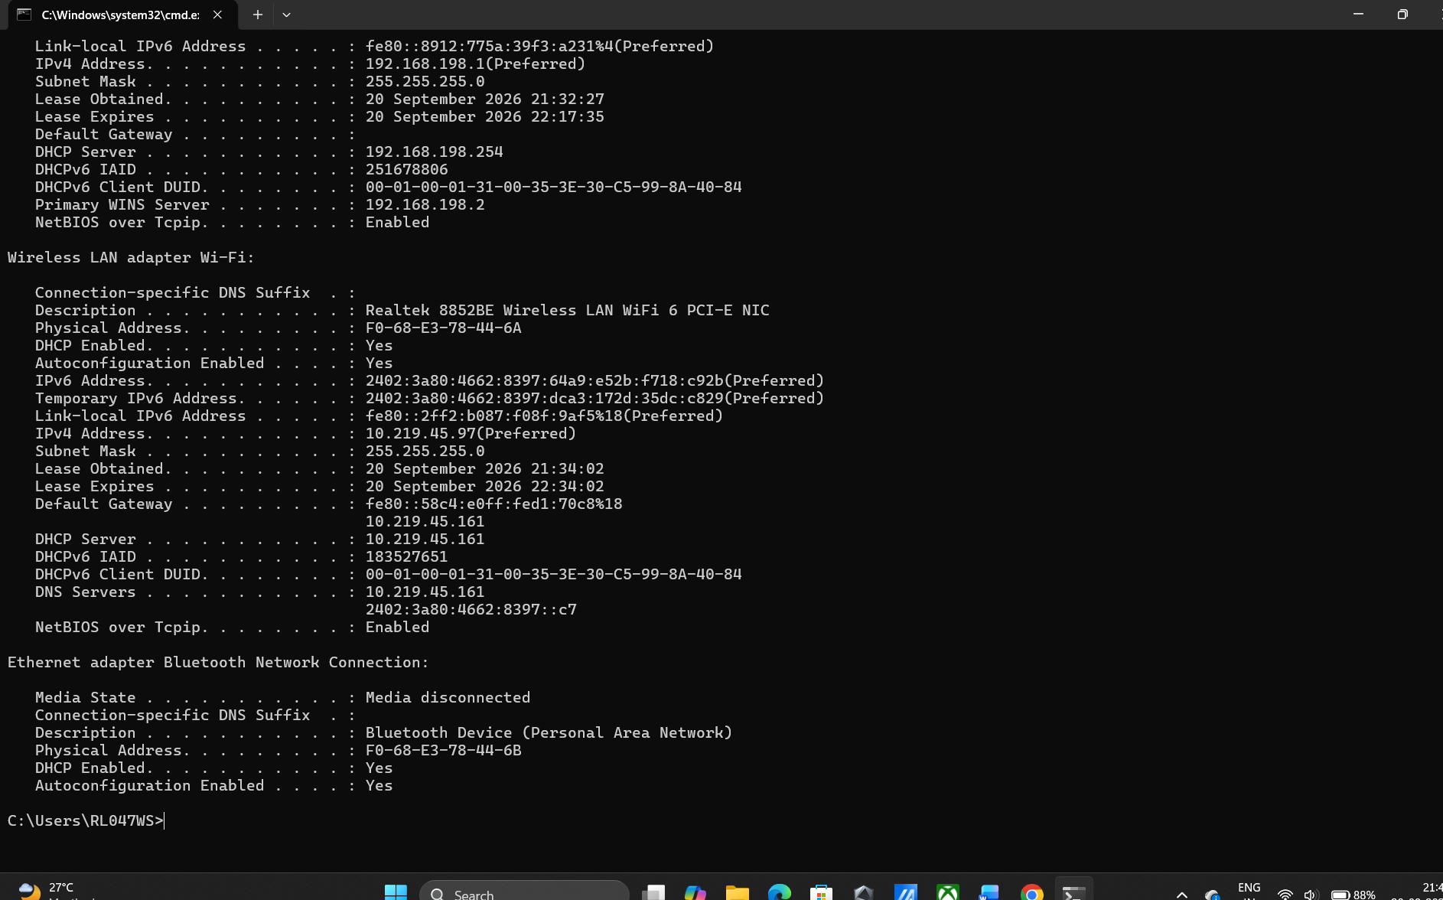

2. Using ping Command :
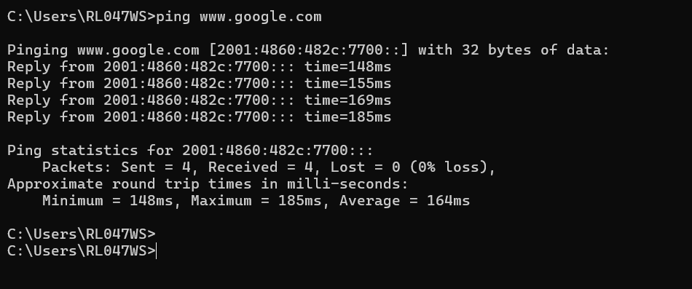

3. Task Manager :

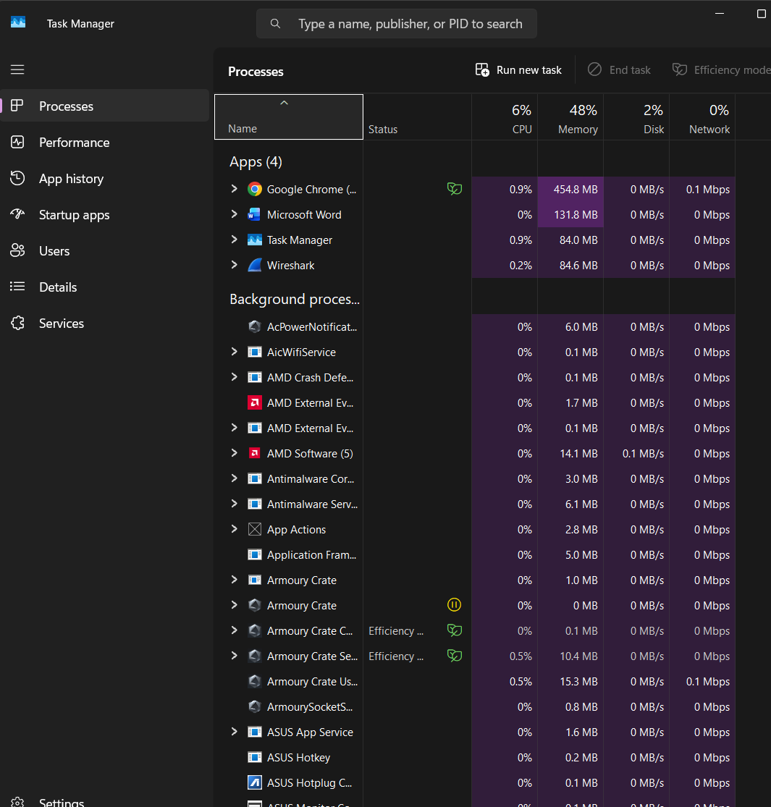

4. Capture Network Traffic on Wireshark :

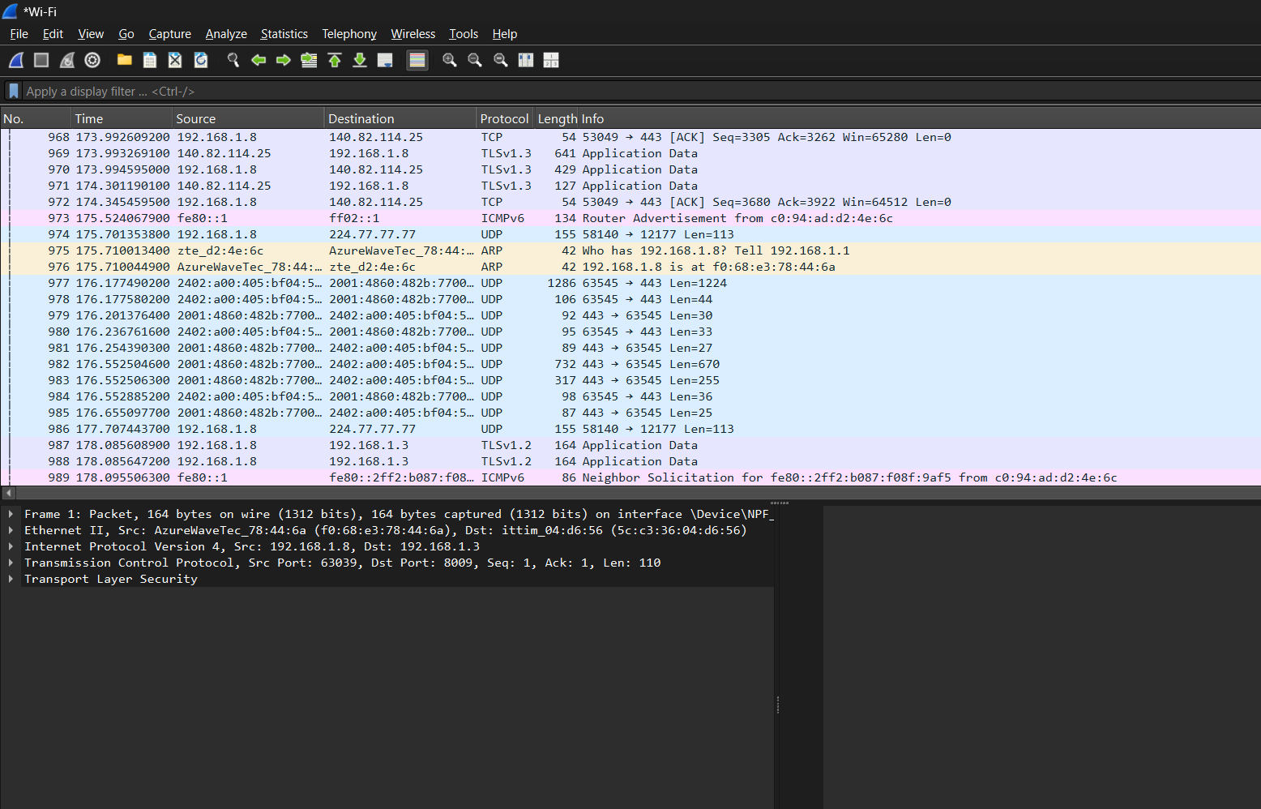

5. Troubleshooting checklist :

AI-Generated Gaming Network Checklist
- Switch to a Direct Wired Cable Connection (Ethernet)
  - Why: Wi-Fi signals get blocked by walls and furniture, causing lag spikes. Plug an Ethernet cable directly from your PC or console into the router for a solid, fast connection.
- Restart Your Router and Modem
  - Why: Routers get overloaded over time. Unplugging the power cord for 30 seconds clears temporary memory and freshens up your network connection.
- Use the 5 GHz Wi-Fi Band (If Cable Isn't an Option)
  - Why: Standard 2.4 GHz Wi-Fi is crowded with signals from phones, smart TVs, and microwaves. Switching your device to the 5 GHz or 6 GHz Wi-Fi network gives you faster speeds and less lag.
- Pause Background Downloads & Turn Off Heavy Streaming
  - Why: Large game updates running in the background or other family members streaming 4K video consume all your home internet bandwidth, causing high ping.
- Enable Quality of Service (QoS) on Your Router
  - Why: Most modern routers let you turn on a setting called "QoS" in their app or control panel, which tells your router to give gaming traffic top priority over other devices.

